KCET 26

# Question 1

what is A in the following reaction ?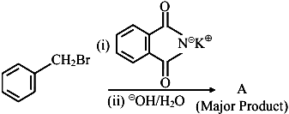

1. 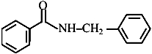
2. image
3. 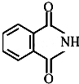
4. image